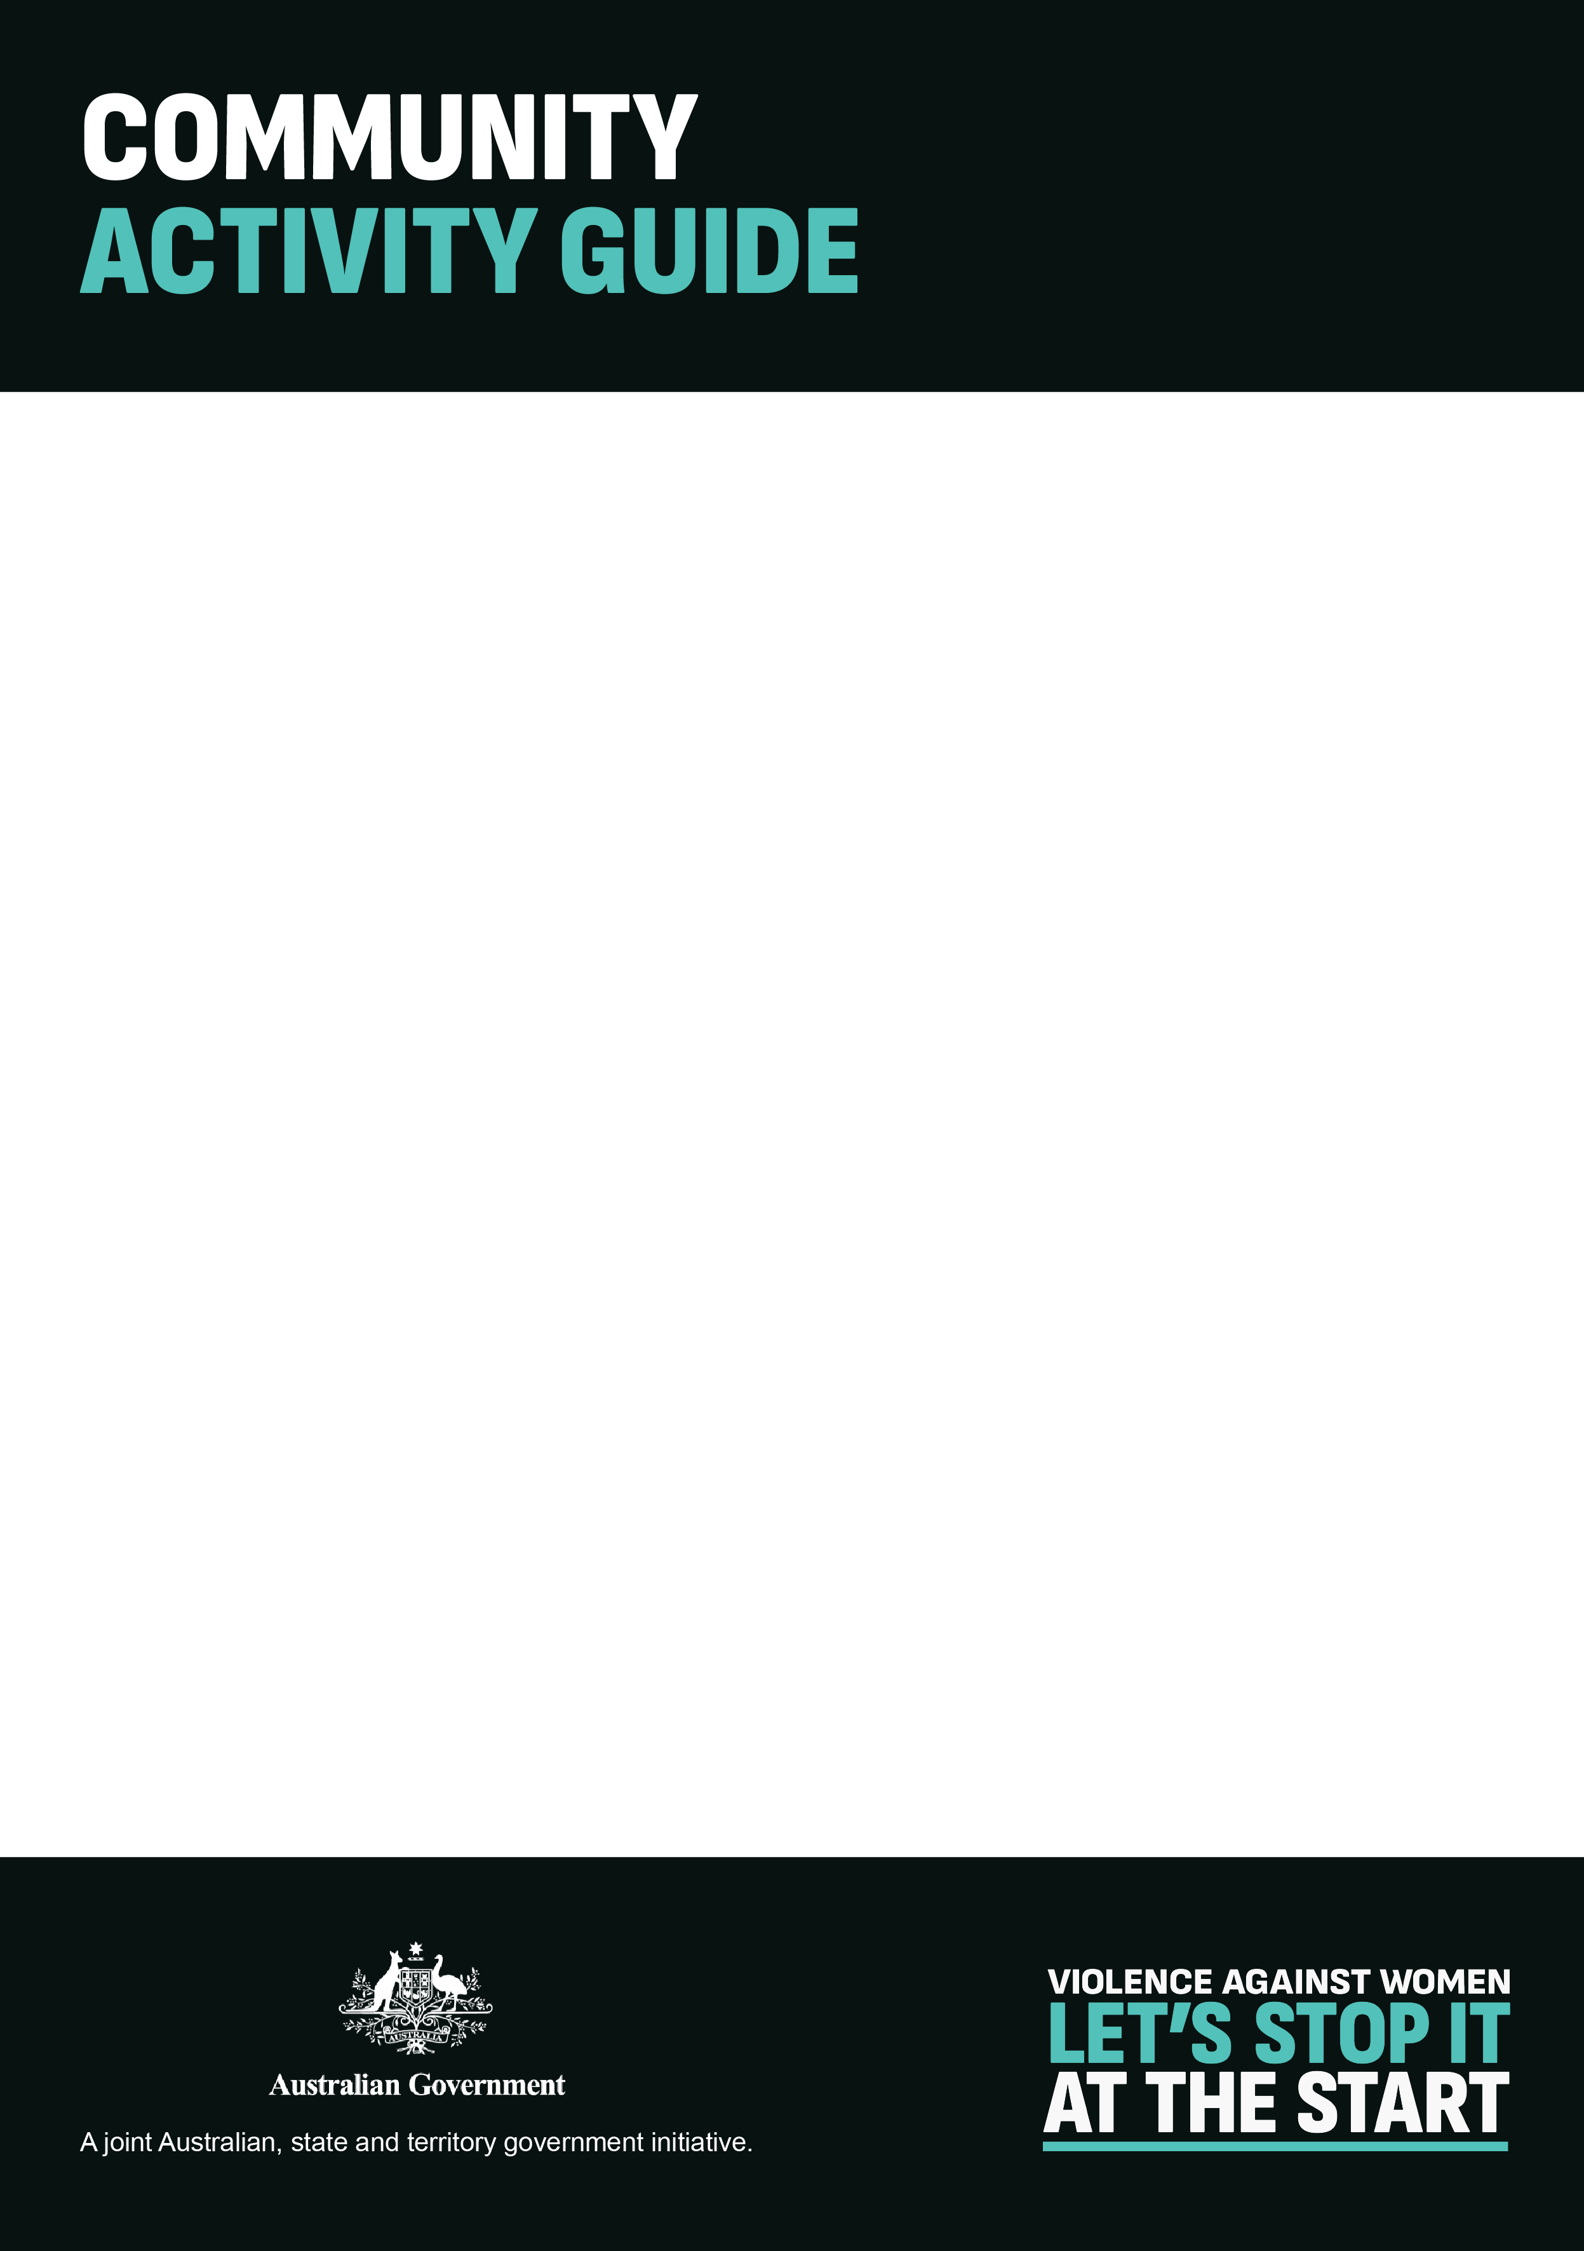

# Stop it at the Start campaign – Community Activity Guide

**There are practical ways we can all promote respectful attitudes and behaviours in our local community.**

## ACTIVITY - Leverage your networks and share what you’re doing

Every community and group is different. Reaching out to your networks can be a great way to share ideas and see what others in your community are doing.

You can:

* Create networks and partnerships to promote your activities and encourage participation.
* Find out what others in your sector are doing and adapt for your own community.
* Share information and resources from the respect.gov.au website in local newsletters or other publications you subscribe to.
* Include this issue as an agenda item on any meetings or official proceedings.
* Take the lessons you provide others home to your family.

**Who it’s perfect for:** All types of faith-based gatherings, local councils, schools and groups..

## EVENT - Host a community workshop

A community workshop session is a great way to engage the wider community in a discussion about respect. By bringing together members from all corners of your community, you can develop a practical plan to make a positive change in your community.

You can:

* Invite a broad range of influencers of young people to attend, such as employers and business leaders, teachers, sporting coaches and members of other community organisations.
* Consider including high profile members of your community, such as local council members.



* Share ***Stop it at the Start*** resources and videos to encourage participants to reflect on their own attitudes and consider their impact and influence on the young people in their lives.
* Together, brainstorm practical activities to promote respect across your local community. These ideas might help you get started.

**Who it’s perfect for:** Any group or organisation in your community.

## EVENT- Hold a morning or afternoon tea

Gathering around an informal meal is a way to bring people together. A morning or afternoon tea is an easy way for people to come together and talk about respect.

You can:

* Host a guest speaker and have them present or facilitate a conversation around respectful relationships, or the role of adults in influencing positive behaviours in young people.
* Invite an internal leader to talk about their commitment to creating a respectful culture within the organisation or group.
* Make posters and resources available in the area for people to take away and read.

**Who it’s perfect for:** Schools, community groups, workplaces, sporting clubs and faith-based organisations.

## EVENT - Dedicate a sporting round to respect

Dedicating a sporting round to respect is a fun, easy way to spread the message amongst players, members and parents.

You can:

* Hold a training session dedicated to talking about respectful behaviours with the team.



* Promote the ‘respect round’ in the team newsletter, or on social media, including links to the respect.gov.au resources.
* Set up a marquee on the day to hand out information and resources from the respect.gov.au website to parents.
* If possible, tie the round to an appropriate day or event, such as the International Day for the Elimination of Violence Against Women on November 25.

**Who it’s perfect for:** Sporting clubs

## CREATE – Respect award or prize

Celebrate respect in your network by highlighting those in your community or organisation who embody respect as a way to encourage respectful behaviour.

Download the Respect Award Certificate template at respect.gov.au and present this to recipients.

You can:

* Create an award or prize that rewards those in your community for their respectful behaviour.
* Promote this initiative through your newsletter, social media or across other internal channels to encourage respectful behaviour in your community.
* Announce the award each month via social media, during your school assembly or following a sporting match.

**Who it’s perfect for:** Community groups, faith-based organisations, local government

## ACTIVITY - Drive a ‘whole of organisation approach’

Creating a ‘whole of organisation’ approach is a great way to encourage respect in your group or organisation.



You can:

* Create a policy on respect and respectful behaviour for your organisation or community group.
* Promote the new policy internally, with posters in the tearoom or an article in the internal newsletter.
* Host a guest speaker and have them present or facilitate a conversation around respectful relationships, or the role of adults in influencing positive behaviours in young people.

**Who it’s perfect for:** Small businesses, sporting clubs, community groups and schools